**Backend of Stock Status**

Stock status is to manage the status of the stocks.

The picture below is the view of the stock status which is you can create, update and delete the item you will created .It shows the reference table 1.1

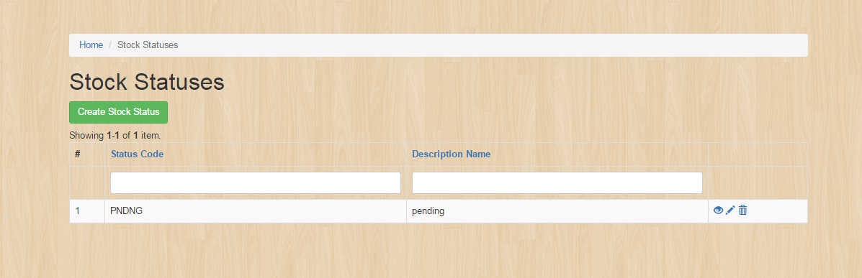

To create a Stock statuses just simply click this button

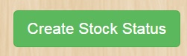

It will appeared this fields

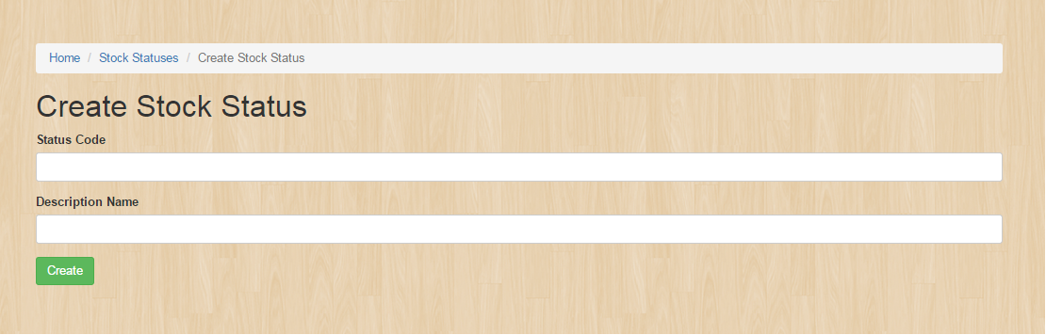

To edit or update the entity see the reference table 1.1 then click the update button.

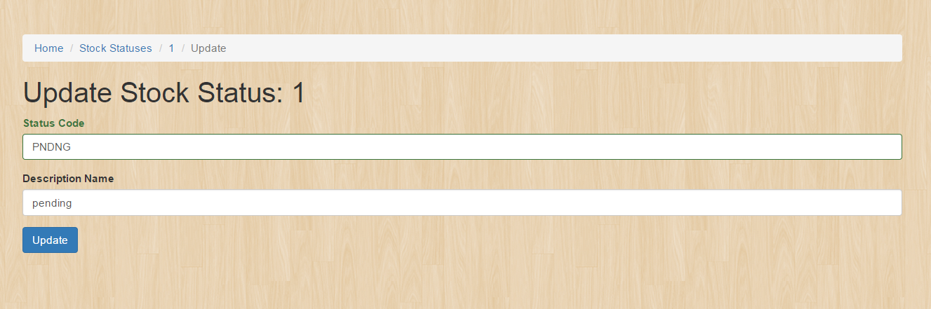

**Backend Stock Issue Details**

The picture below is to view the stock issue details which is you can create, update and delete the item you will created .It shows the reference table 1.1

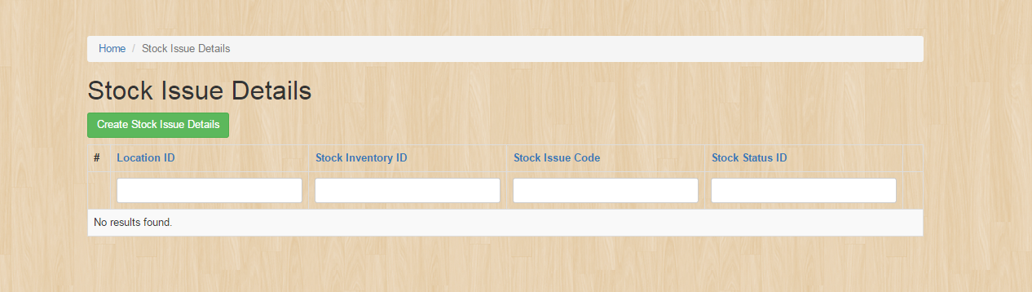

To create a stock issue details click this button.



Fill up this form to create an entity in the stock issue details.

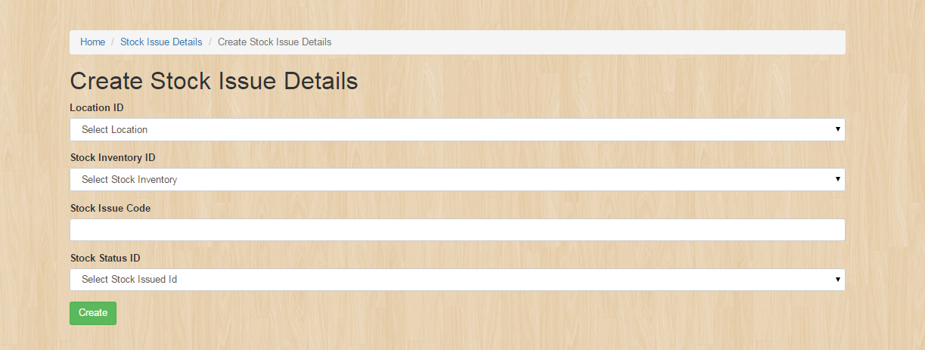

To edit or update the entity see the reference table 1.1 then click the update button.

**Backend Item Category**

The picture below is to view the item category which is you can create, update and delete the item you will created .It shows the reference table 1.1

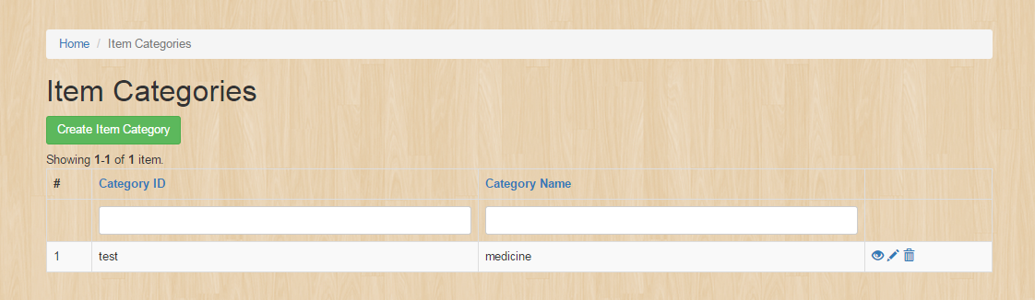

To create an item category details click this button.



Fill up this form to create an entity in the Item category.

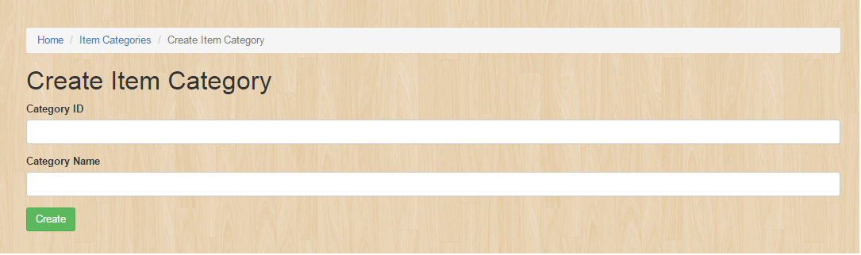

To edit or update the entity see the reference table 1.1 then click the update button.

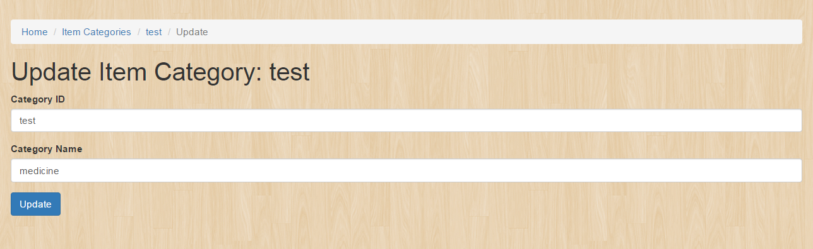

**Backend Return Item Header**

The picture below is to view the item category which is you can create, update and delete the item you will created .It shows the reference table 1.1

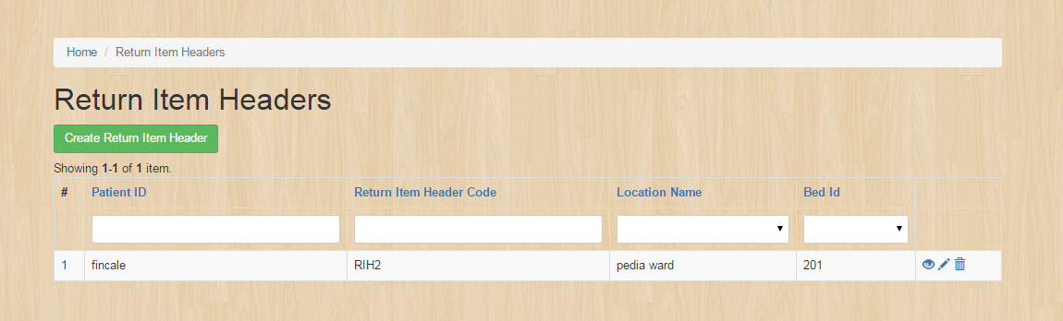

To create a Return item header details click this button.



Fill up this form to create an entity in the Return Item Header.

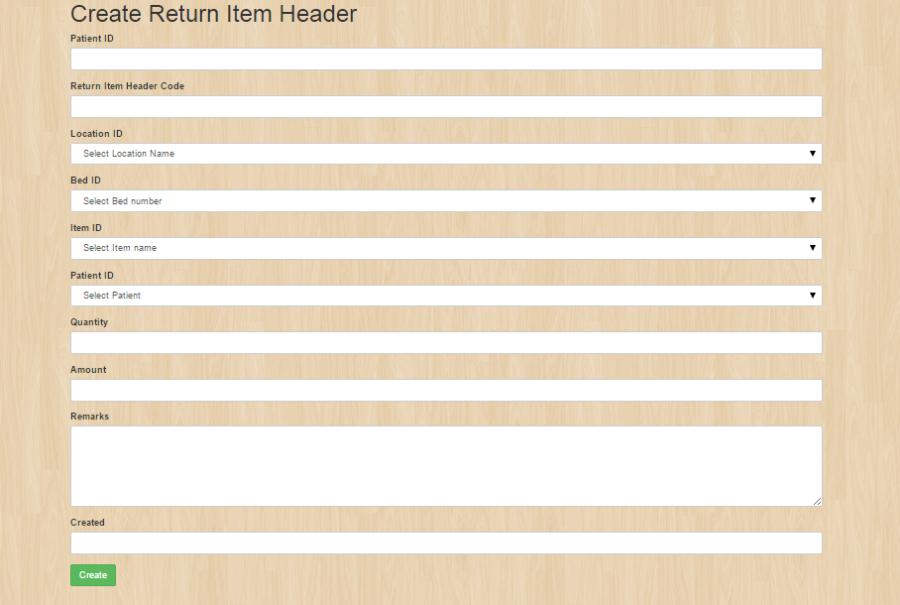

To edit or update the entity see the reference table 1.1 then click the update button.

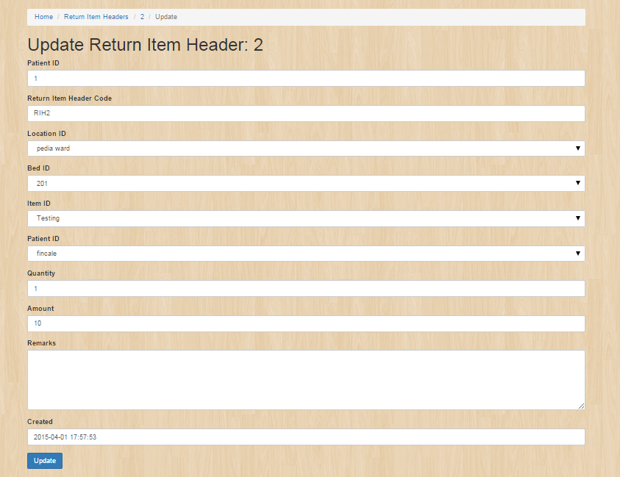

**Backend Patient**

The picture below is to view the patient which is you can create, update and delete the item you will created .It shows the reference table 1.1

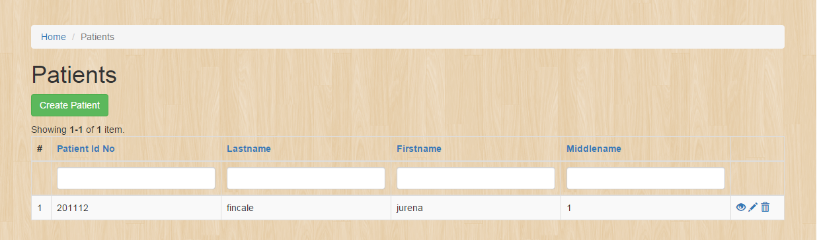

To create a patient details click this button.



Fill up this form to create an entity in the patient.

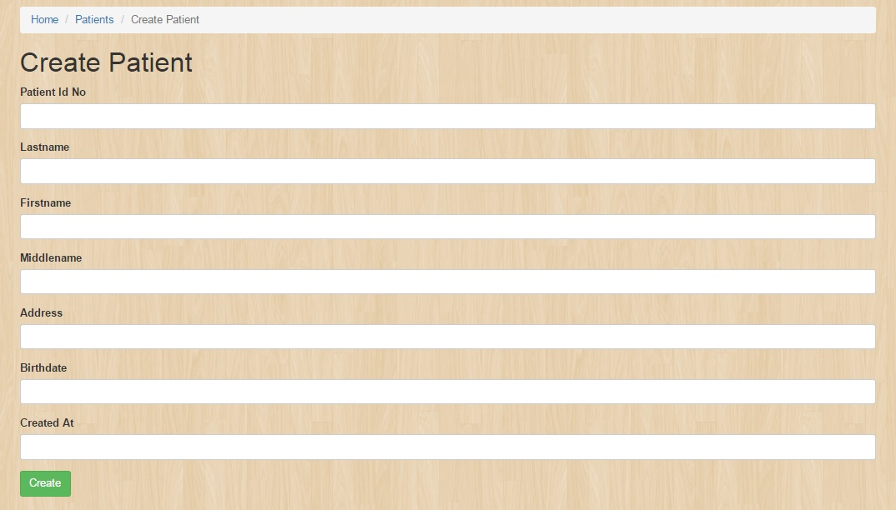

To edit or update the entity see the reference table 1.1 then click the update button.

